**Higher Diploma in Computing – Part-Time 2014**

**Semester 3**

**Course Module: Software Engineering for Web Applications**

**(**HDC-SEWA)

**Main Assignment – ER Diagram**

**Student Names: Gavin McGovern, Frank Deasy, Cathal Mulkere**

**Student ID Nos.: 2862213, 2864260, 2859287**

**Lecturer: Mark Scanlon**

**Date Due: 05-01-2015**

Functional Specification

We are building a new website with a login function linked to a database containing the Static Data, Training Programme and Match Performance with Statistics of Gaelic Footballers:

*Functionality Required:*

- Ability to analyse the match performances of all players recorded relative to the training they have done on a weekly basis i.e. if a player has worked more on fitness in a particular week how does this affect his distance covered (which would be deemed related) and how does this affect his scoring ability (not necessarily related).

- Capacity for users to enter their own static data, training regimes and performances and run simulations against the best players in the game

- Additional ability to know the scoring records, injury and disciplinary points at a point in time for any player entered.

Design Assumptions

Based on the above specifications, a number of critical functions and features of the database are set out below:

* There is a clear need for Team, Player, Match and Training data separately with particular focused analysis on the Training and Match Performance of individual players.
* While Teams and Players will generally have specific set data unlikely to change, Match and Training Data will need to be recorded over time and thus for Table purposes, primary keys will include Dates.
* We will allow the capability for club players and club analysis but for the time-being the focus will be on inter-county and thus the possible comparisons available for users will be to review the data of inter-county players.
* Key Data to be recorded:
* User Details
* Team: Name, Manager, etc.
* Player: Name, DOB, Standard Position, etc.
* Match: Dates, Venues, Results(if available), Teams, etc.
* Match Performance: Scores, Cards, and the general key stats for a player
* Training: Type (e.g. Personal / County), Date, Total Hours, What was done
* Note: Much of the appearance data included in the database design has been deemed not core to functionality of the website in its current format but was included to enhance potential functionality.

Tables and Attributes:

Based on the final design of the Database the following attributes have been included in the associated Entity Tables:

|  |  |  |
| --- | --- | --- |
| **Entity** |  |  |
| Users | **Username[PK]**  Password | Name  User Email Address |
| Teams | **Name[PK]**  Level (i.e. club, county etc.)  County (if a Club Team) | Province (if a Club or County Team)  Manager  County Grounds |
| Players | **Name [PK]**  DOB  Gender  Height(in meters) | Club  County  Position |
| Matches | Team A  Team B  Team A Goals  Team A Points  Team B Goals  **(Team A, Team B, Date [PK])** | Team B Points  Type  Date  Length(in minutes)  Venue |
| Training | Player Name  Date  Status (i.e. if injured)  Type (i.e. club, personal, county, etc.)  **(Player Name, Type, Date [PK])** | Skills Minutes  Fitness Minutes  Gym Minutes  Recovery Minutes |
| Match Performance | Player-Name  Match-Date  Match-Type  Minutes Played  Distance Covered (in meters)  Number of Possessions  Number of Possessions in Scoring Zone  Possessions Won By Clean Catches  Possessions Won By Tackles / Turnovers  Passes Complete  Hand Passes Completed  Foot Passes Completed  Passes Incomplete  Attempts (i.e. shots at goal)  **(Player-Name, Match-Date, Team [PK])** | Shots On Target  Shots Wide  Saves  Goals  Points  Points From Frees  Tackles Made  Frees For  Frees Against  Attacking Runs  Defensive Runs  Red Card  Yellow Card  Black Card |

ER Diagram:

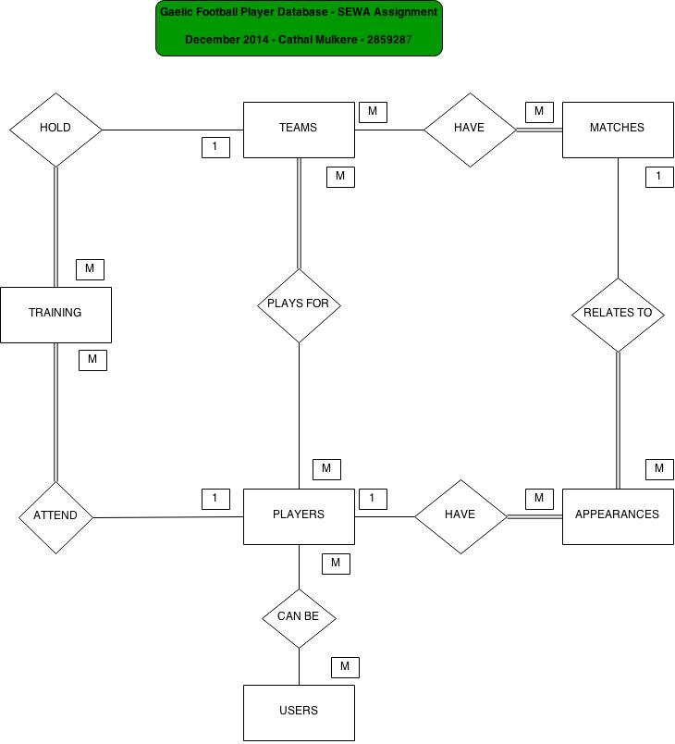

Appendix – ER Diagram Development

## ER Diagram Preparation

* 1. **Identification of all possible entities based on specifications**
  2. **Removal of duplicate entities (if applicable**

User

Team

Venue – Not relevant with the specification of this database - Attribute of Match

Player

Matches

Training

Match Performance

Training Performance – Not required but a scalable add on

Competition – Attribute of Match

* 1. **List the attributes of each entity; and,**
  2. **Mark the Primary Keys(or Foreign Keys where applicable)**

*See Main Document*

* 1. **Defining the relationships between entities(These will be refined from 1.6 below)**

|  |  |
| --- | --- |
| **Entity** | **Attributes** |
| Users | User can be Players |
| Teams | Teams have Players  Teams have Matches  Teams hold Training |
| Player | Players attend Training  Players have Appearances in Matches |
| Matches | Matches relate to Appearances |
| Appearances | See above |
| Training | See above |

* 1. **The Cardinality and Optionality of each relationship – Mappings:**
* 1 User can enter data for Many Players while 1 Player’s data can be entered Many Users:

M

**PLAYERS**

M

**USERS**

ENTER DATA FOR

* 1 Player can play for Many Teams while 1 Team must have Many Players:

PLAY FOR

M

M

**TEAMS**

**PLAYERS**

* 1 Team can have Many Matches while 1 Match must have Many teams:

PLAY

M

M

**MATCHES**

**TEAMS**

* 1 Team can hold Many Trainings while 1 Training must have 1 Team:

HOLD

1

**TRAININGS**

**TEAMS**

M

* 1 Player can attend Many Training Sessions time and 1 Training Session must involve 1 Player:

HAS

**TRAINING**

M

1

**PLAYER**

* 1 Player can have Many Appearances while 1 Appearance must involve 1 Player:

**MATCH PERFORMANCE**

**PLAYER**

M

1

HAS

* 1 Match can relate to Many Appearances(Matches can also be fixtures with no associated appearance initially) while 1 Appearance must relate to 1 Match:

RELATE TO

**APPEARANCE**

1

M

**MATCH**

* 1. **Review for Fan-Traps(“1:M relationships”) and Chasm Traps(“M:1 relationships”)**

We have not dealt with Fan or Chasm Traps in E.R. Diagram Development at this time.

* 1. **Identify entities with the most relationships**

Based on the above, we can see that the following entities have the greatest number of relationships in descending order. This will assist in completing our E.R. Diagram:

1. Players are involved in 4 Relationships
2. Teams are involved in 3 Relationships
3. Training are involved in 2 Relationships
4. Matches are involved in 2 Relationships
5. Appearances are involved in 2 Relationships
6. Users are involved in 1 Relationship
   1. **Complete ER Diagram using** [**www.draw.io**](http://www.draw.io)

We have completed an initial more concrete version of our ER Diagram using [www.draw.io](http://www.draw.io). This is set out in the main document